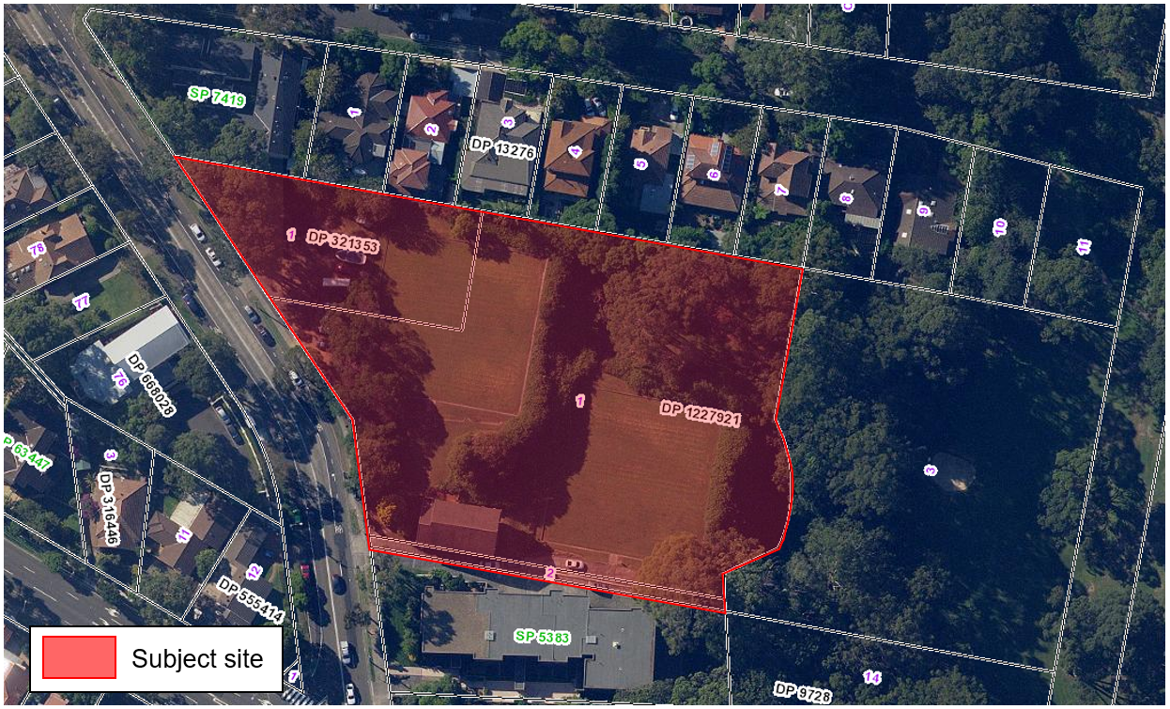
Figure 1: Site map (source: SIX Maps).
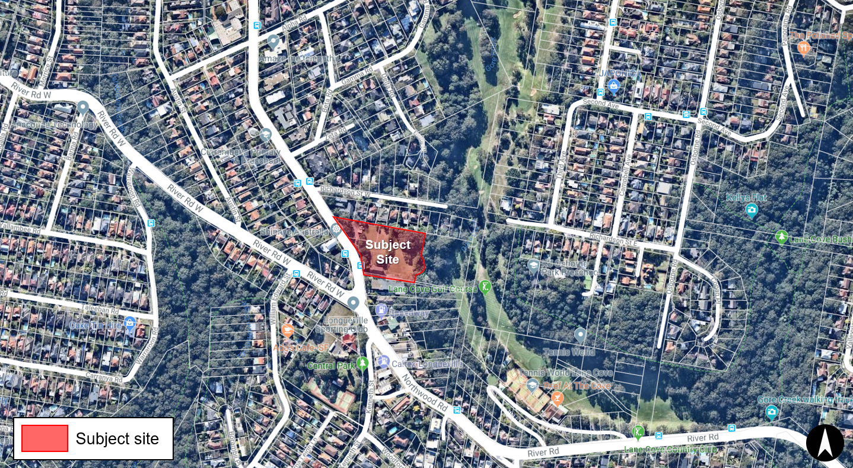
Figure 2: Site Location Map (source: Nearmap).
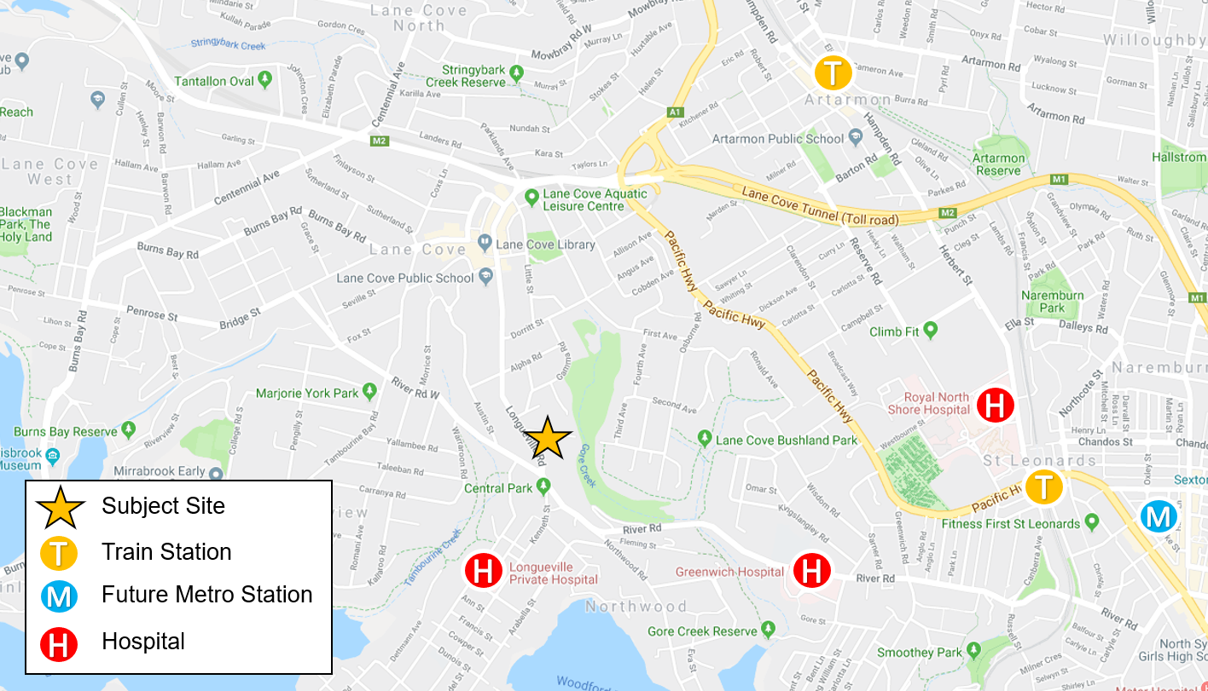
Figure 3: Locality Map (source: Google Maps).

